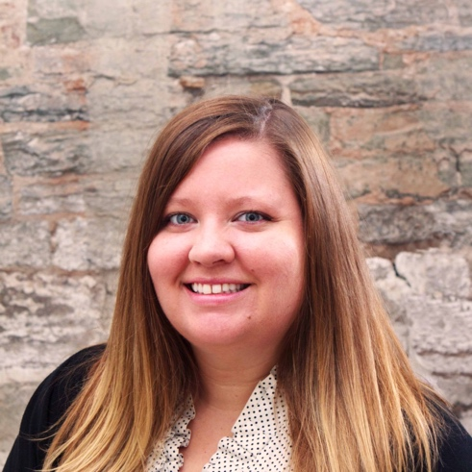
Allison Smith Steffenhagen graduated from the University of Wisconsin-Stout in 2006 with a B.A. in Psychology with a specialization in International studies and an emphasis on French area studies.

While studying in France, Allison volunteered at a local elementary school and met with a variety of Vallée de la Loire regional government leaders, with a focus on learning how to work across different cultural norms in business.

From 2008-2014 Allison worked at Lowertown Lofts Apartments in Saint Paul, Minnesota as lead concierge and leasing consultant. In 2010, Allison was nominated for a MADACS award for best leasing consultant in the state of Minnesota. She was certified as a concierge with the National Concierge Association (NCA) in 2012. In 2013 she won the Minnesota NCA Volunteer of the Year award and went on to also win at the national level.

Allison began working in Diversity, Equity, and Inclusion as a programming director at Events by Lady K, centering Universal Design while creating event and work spaces. Highlights of her time at Events by Lady K include creating programming for bushCONNECT with the Bush Foundation in Saint Paul, MN and managing the events team for the Minnesota Super Bowl Host Committee Legacy Fund in 2017.

As a DEI consultant, Allison works with multiple organizations as a project manager and a Qualified Administrator of the Intercultural Development Inventory (IDI). Allison’s client list includes; Beth Zemsky Consulting, Evolutionary Consulting, IDI LLC, Intercultural Development Group LLC, One Ummah Consulting and The Wild Institute.

In her free time, Allison enjoys traveling with her spouse, cuddling with their two cats, and the practice of meditation.

