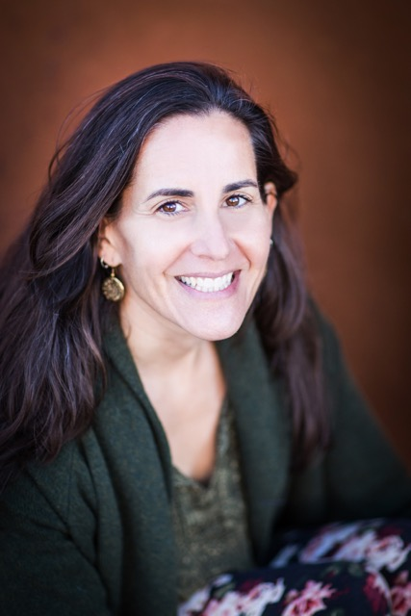
Julia Hobday brings over 20 years of personal and professional experience in racial equity and intercultural development to her practice. She is a bridge builder, able to connect diverse perspectives in various environments. Julia helps both individuals and organizations move forward in their capability to work across difference toward their equity and inclusion goals. Many people and organizations know they want to be more equitable, but don’t know what that means and what that might look like. Julia helps build an understanding of where an individual or organization is and where they want to be, and illuminates a path to get them there.

Julia is a Qualified Administrator (QA) for the Intercultural Development Inventory (IDI). She is a trained Racial Justice Facilitator and holds an Advanced Certificate in Equity and Diversity from the University of Minnesota. Julia uses her skills both in a professional capacity as a consultant and in her role as a volunteer in many community organizations including: FREC (Facilitating Racial Equity Collaborative); YWCA MN Racial Justice program; St Joan of Arc Anti-Racism Core Group; St Paul Public Schools; and Project TRUST (Training for Resiliency in Urban Students and Teachers). Working in community with others for cultural change and justice is a value she holds dear.

